AMAZON S3 DATABASE CONNECTION

In (IIB) or App Connect Enterprise (ACE), the Amazon S3 Request node is used to connect and interact with AWS S3 (Simple Storage Service) — a cloud-based object storage service.
This node allows IIB/ACE flows to perform operations like uploading, downloading, deleting, or listing files in S3 buckets
Buckets:
‘It's a fundamental component of S3, acting as the primary container for storing and retrieving data as objects’.
A banking application processes millions of transactions daily. After processing, each transaction's confirmation or audit log is generated as a JSON or PDF file. These files must be stored securely and durably for compliance reasons.
Amazon Simple Storage Service Request node operations are synchronous and free, meaning that if the message flow fails and recovers after the Amazon S3 Request node, the data source operation will still be complete. To integrate with Amazon Simple Storage Service we have to follow some configuration steps. They are:
- Create an Amazon S3 account.
- Create an IAM user in IAM (IAM user is an identity with long-term credentials that is used to interact with AWS in an account).
- Generate and copy the security credentials for the IAM user (access key Id & secret access key).
- Create A simple flow and policy to perform Creating objects with data in the bucket.
- Click on Launch connector discovery of amazon s3 request node.
- Connect the Amazon s3 account with security credentials and select the Action, operation, and bucket.
- Close the connector discovery; deploy & test the application.
- Given below is the Response to retrieve the operation of an object data in an amazon s3 account.
- CREATION OF THE BUCKET IN S3 USING IBM ACE.

Create policy to perform Creating objects with data in the bucket.
POLICY NAEM
- STEP:1 ) CONNECT TO THE S3 USING CONNECTOR Discovery
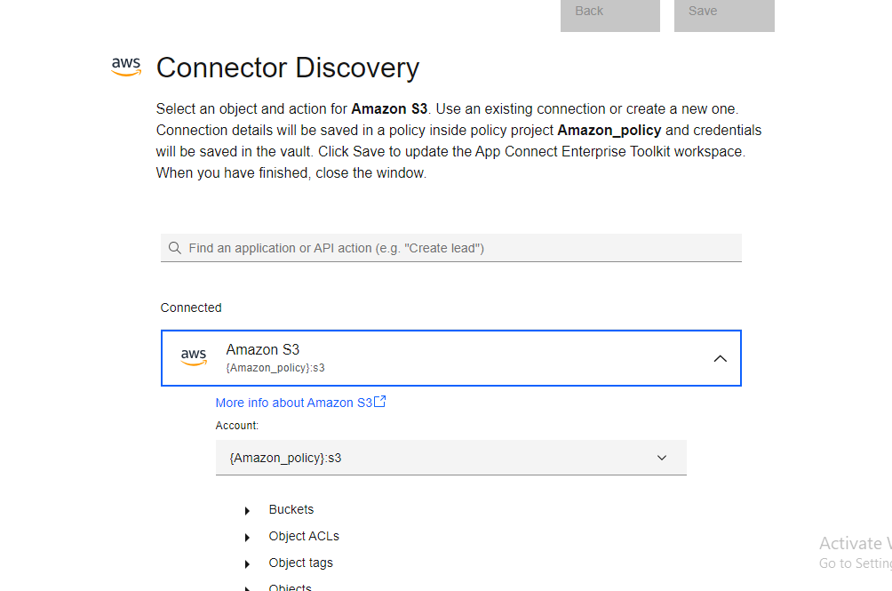
Select the option BUCKETS IN WHICH SELECT THE” CREATE THE BUCKET ”
ADD
SPECIAL ACCESS KEY ,
ACCESS KEY ID ,

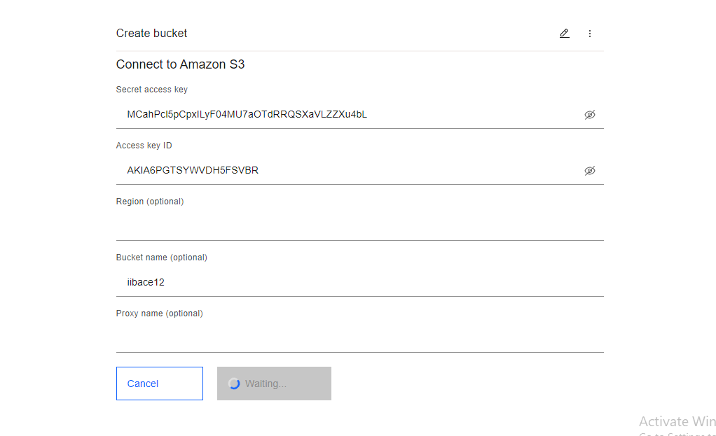
Wait for the process to be done
Once done save it .
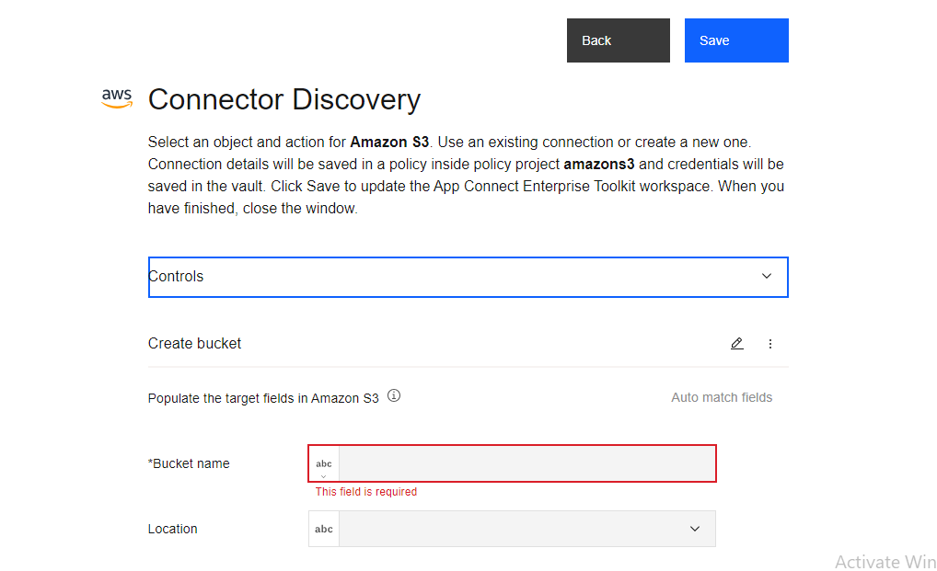

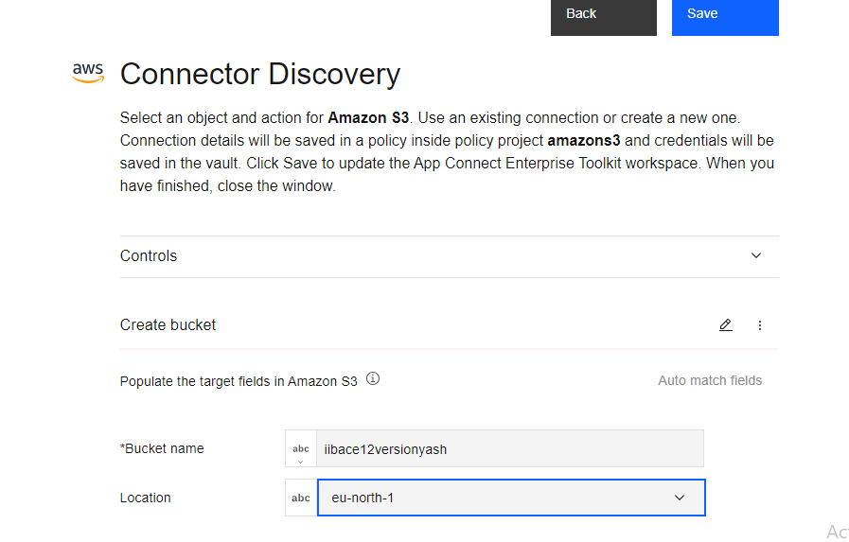
Add bucket name and location as per amazon s3

STEP 2 ) CREATE THE MASSAGE FLOW AS PER GIVEN
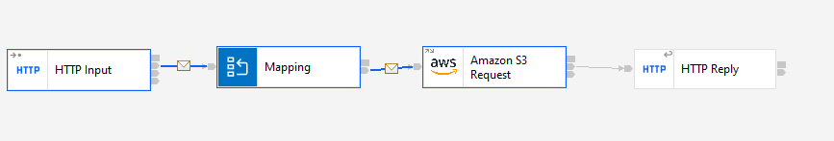

USING MAPPING ADD THE REQUIRED INPUT
PUT THE NAME OF THE BUCKET U NEED TO CREATE IN INPUT MASSAGE. ALSO ASSIGN THE VALUE OF THE NAEM TAG AS BUCKET NAME TAG .

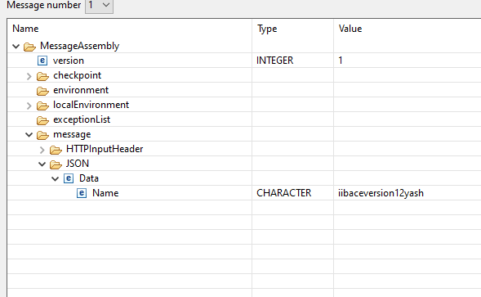
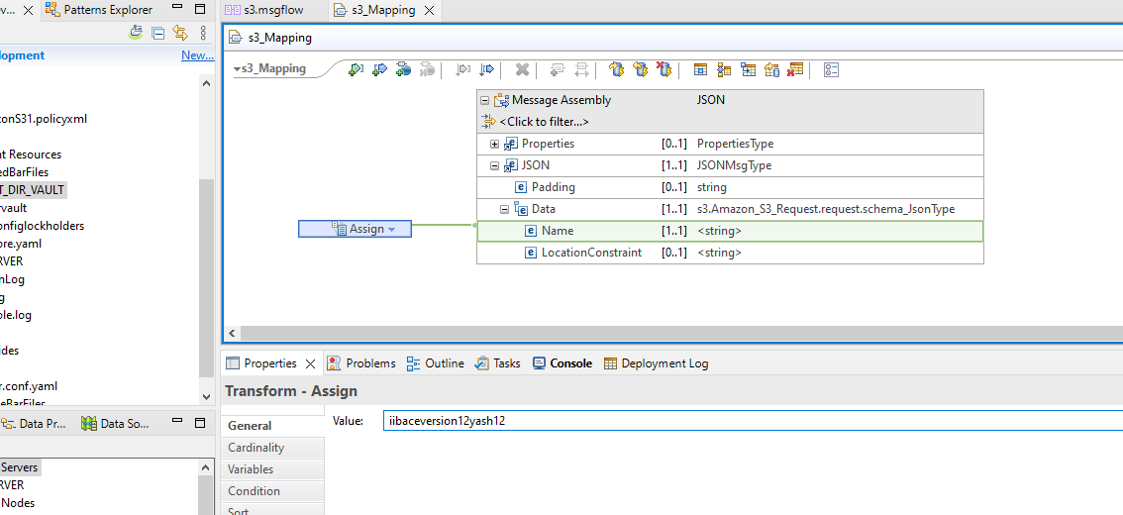
BELOW U CAN SEE NEWLY CREATED BUCKET IS PRESENT
